K-Means Python Application
Executive Summary
The main objective was to deploy K-Means clustering through weather data analysis for distinguishing various weather patterns. The goal was to perform clustering based on temperature with wind speed and humidity data through Python-enabled compartments between Jupyter Notebook and PyCharm.
The project started by building a weather dataset which needed data cleaning operations and formatting procedures. The preprocessing required normalization of numerical features through StandardScaler to generate equal variable weights for KMeans distance calculations. The clustering procedure divided data points into three specific clusters which corresponded to different weather condition groups.
The developmental process brought forward multiple roadblocks. There were errors that occurred when running the KMeans implementation PyCharm which gives AttributeError: 'NoneType' object has no attribute 'split'. But when executed in Jupyter Notebook, it gives results. The difference in execution between environments showed distinct ways they deal with variable states as well as object outputs and cell execution. The issue resided in uninitialized or overwritten data structures that returned None because of incorrect baseline settings and data preprocessing absence in PyCharm.
I addressed this problem by implementing proper data loading and preprocessing for clustering and validating data structure together with data type at each processing stage. Visualizations using matplotlib and seaborn demonstrated that the observations with similar patterns got properly clustered.
The implementation of K-Means clustering succeeded in analyzing both authentic weather records as well as fabricated data. The practical application demonstrated that data preprocessing needs to be thorough and developers must establish stable programming spaces and debugging processes to succeed with machine learning operations between Jupyter and PyCharm development frameworks. The K-Means clustering plot shows that temperature and wind speed data form three distinct weather clusters which appear as blue, orange and green regions. Cluster 0 colors blue while showing temperatures in the warm range with moderate wind velocity which likely indicates a peaceful mild weather condition.
The conditions within Cluster 1 (Orange) show both minimal temperature levels and negligible wind velocity indicating a combination of cold weather with no wind movement. The cluster named Green shows a wide temperature range along with stronger wind speeds which indicates conditions between stormy weather and variable patterns. The black X markers show cluster centroids which prove the clusters are distinct and meaningful.

Appendix A : Pycharm
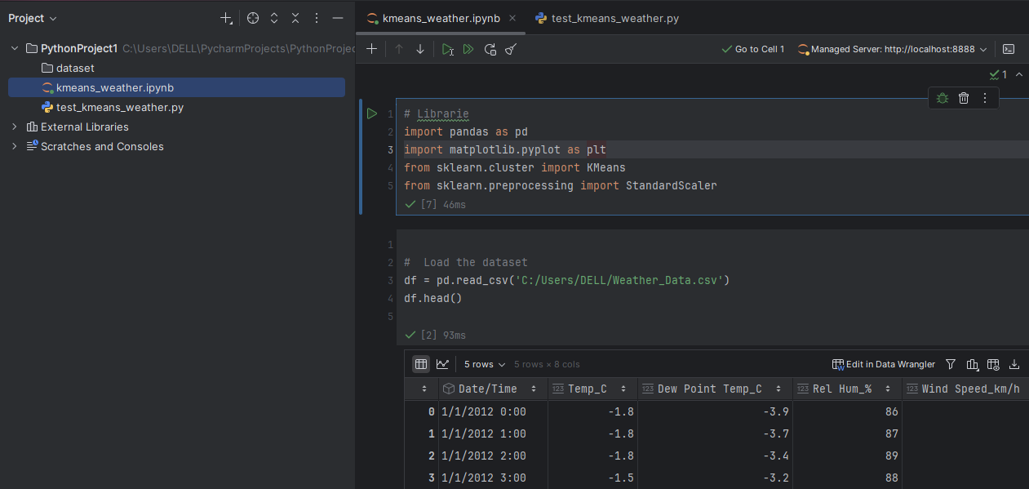
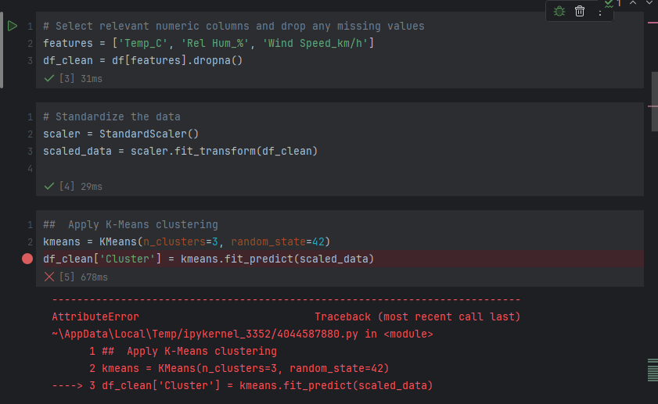
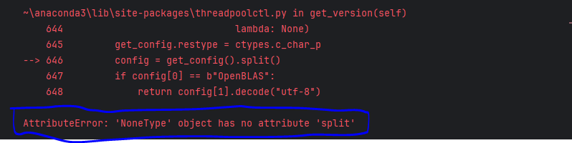
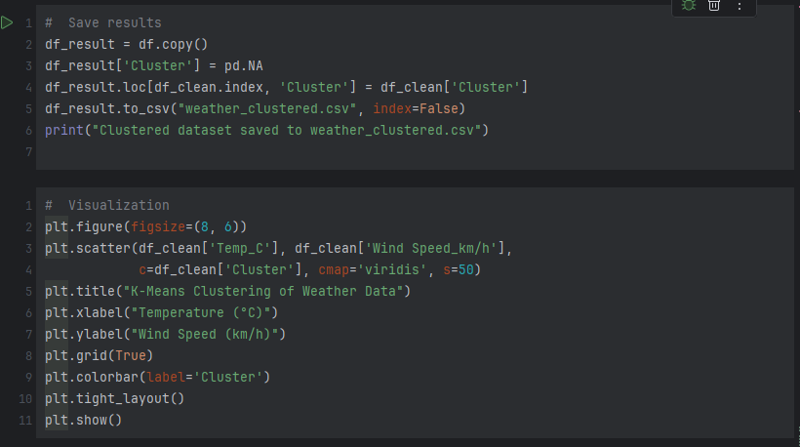
Appendix B : Unit test

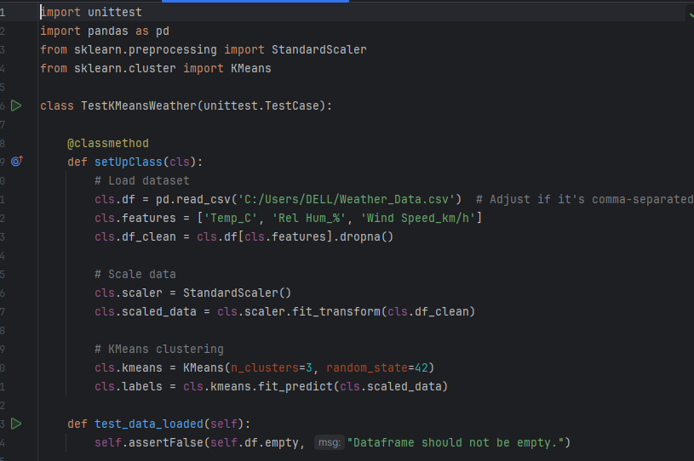
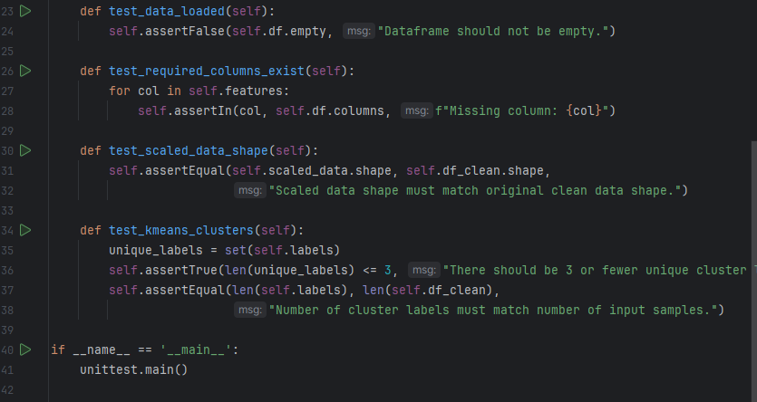
Appendix C : Jupyter Notebook
